First run the sheldon1 file using “ chmod +x sheldon1” command and “./sheldon1” command.

Then open it using gdb.

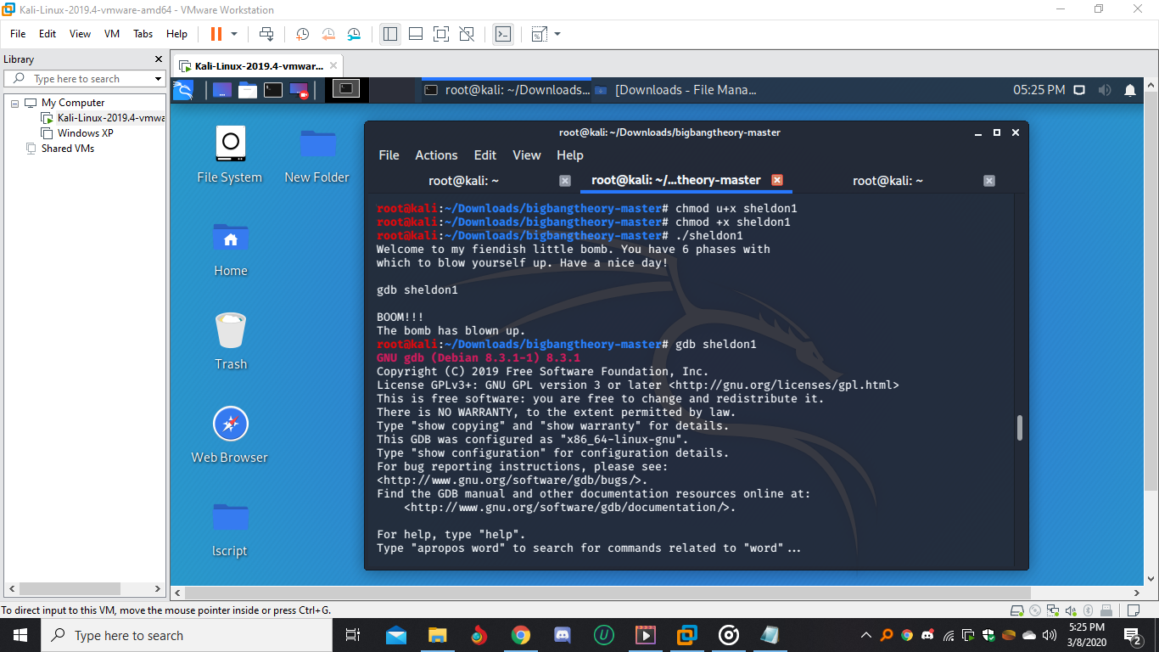

Look for the functions inside sheldon1 using the command “info functions”.

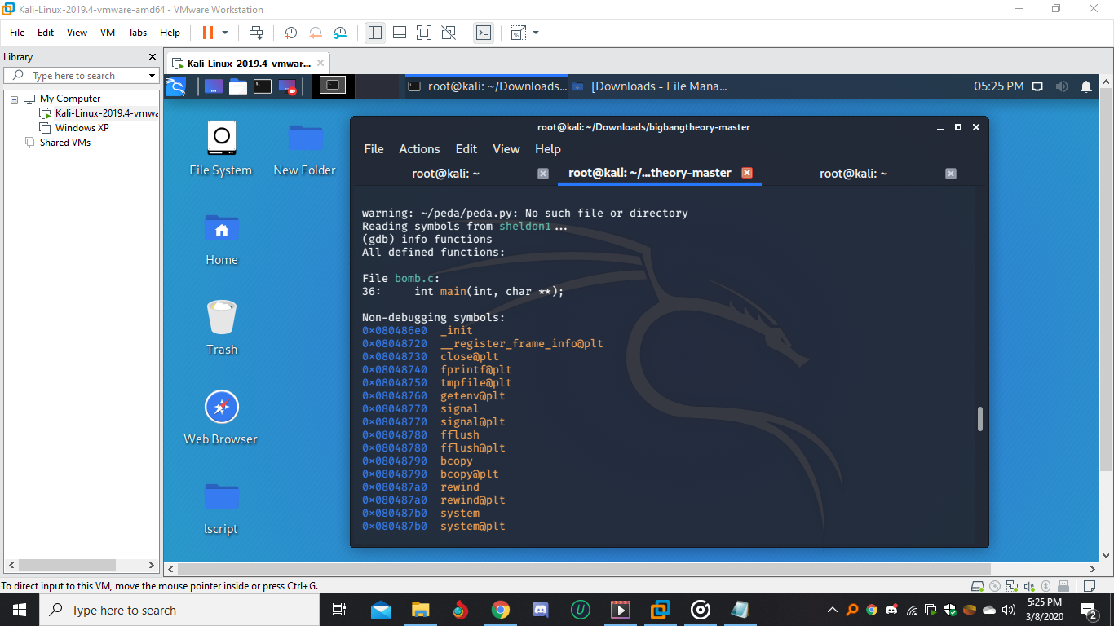

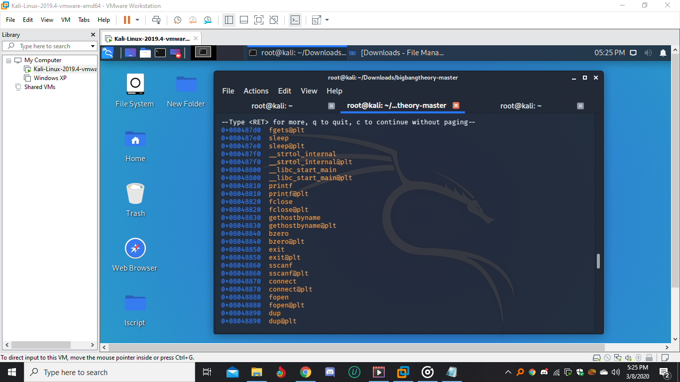

Then view the assembly code of the main function using “ disassemble main” command.

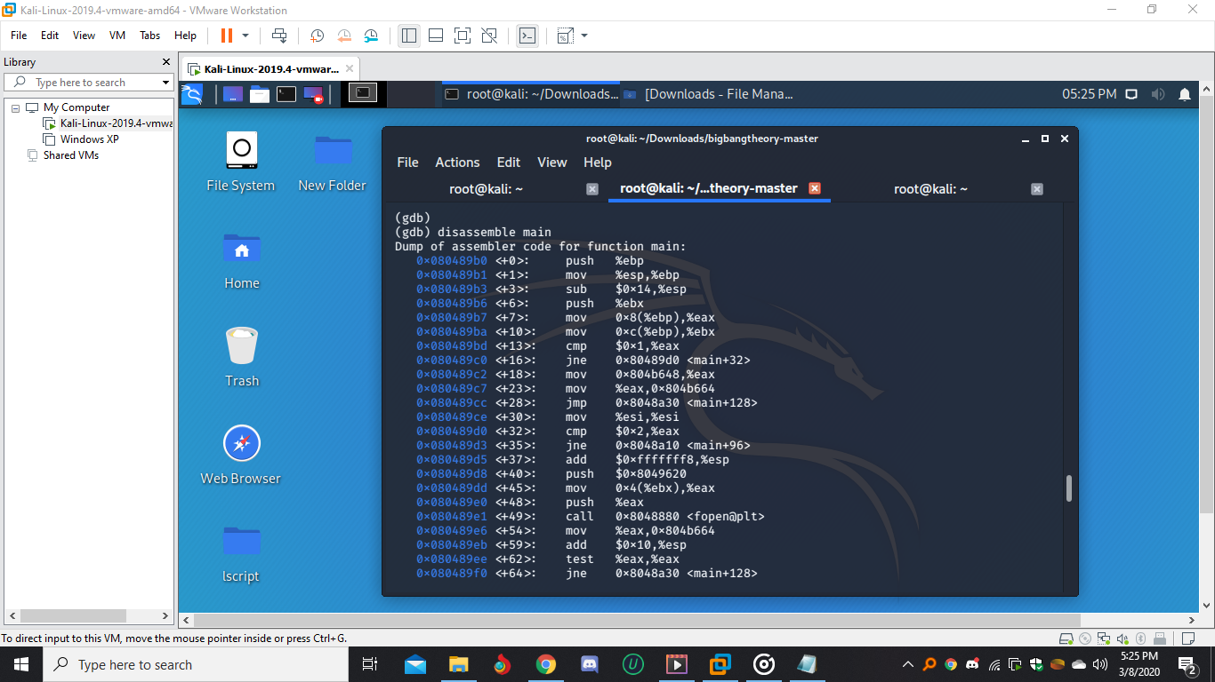

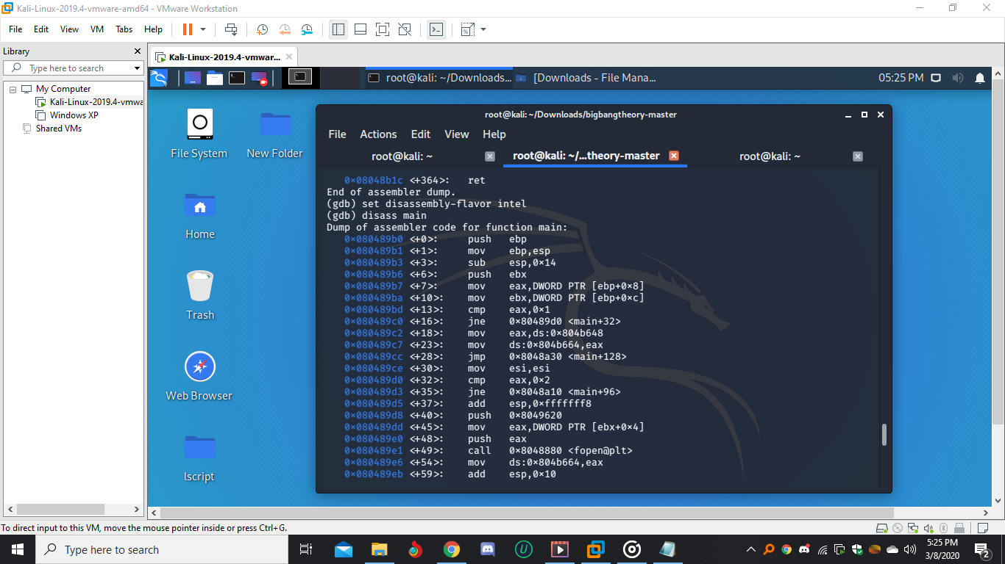

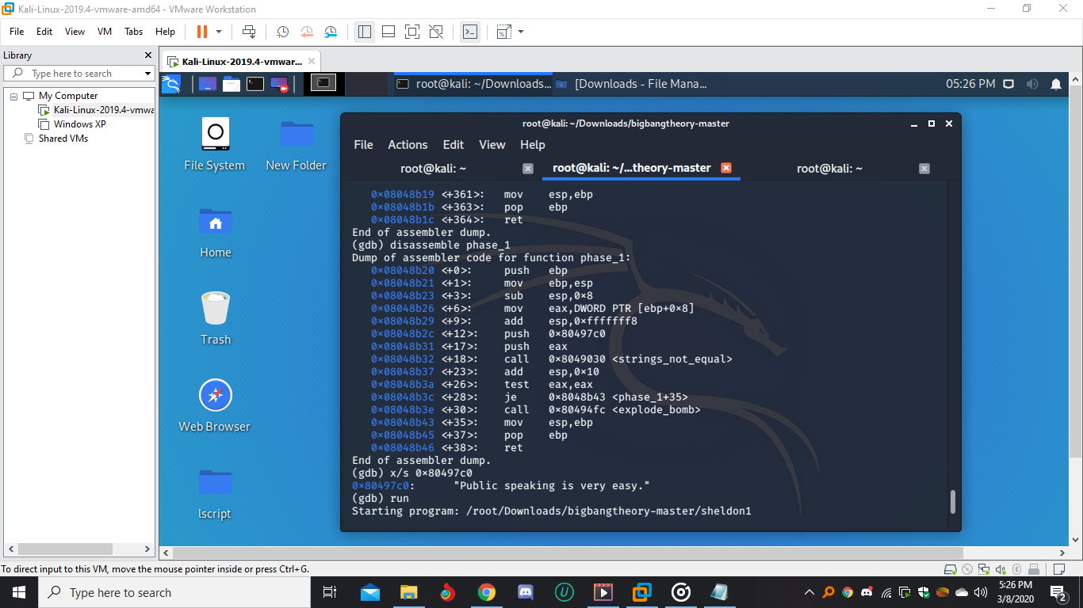View the assembly code of the phase_1 using “ disassemble phase_1” command.

By looking into the 0x80497c0 memory location we could found the “Public speaking is very easy.” String.

